Invitations:
- Focus on the artists’ rendition. Noticing what you see, what story do you see as you look at the tile?
- Focus on the title of the stations. What does it meaning does it hold for you?
- Read the suggested mediations taken from Bishop Mark Andrés and Matthew Fox. Notice if and how they speak to you.
- Notice how the deepest sense of Self comes alive as you give your attention to the stations.
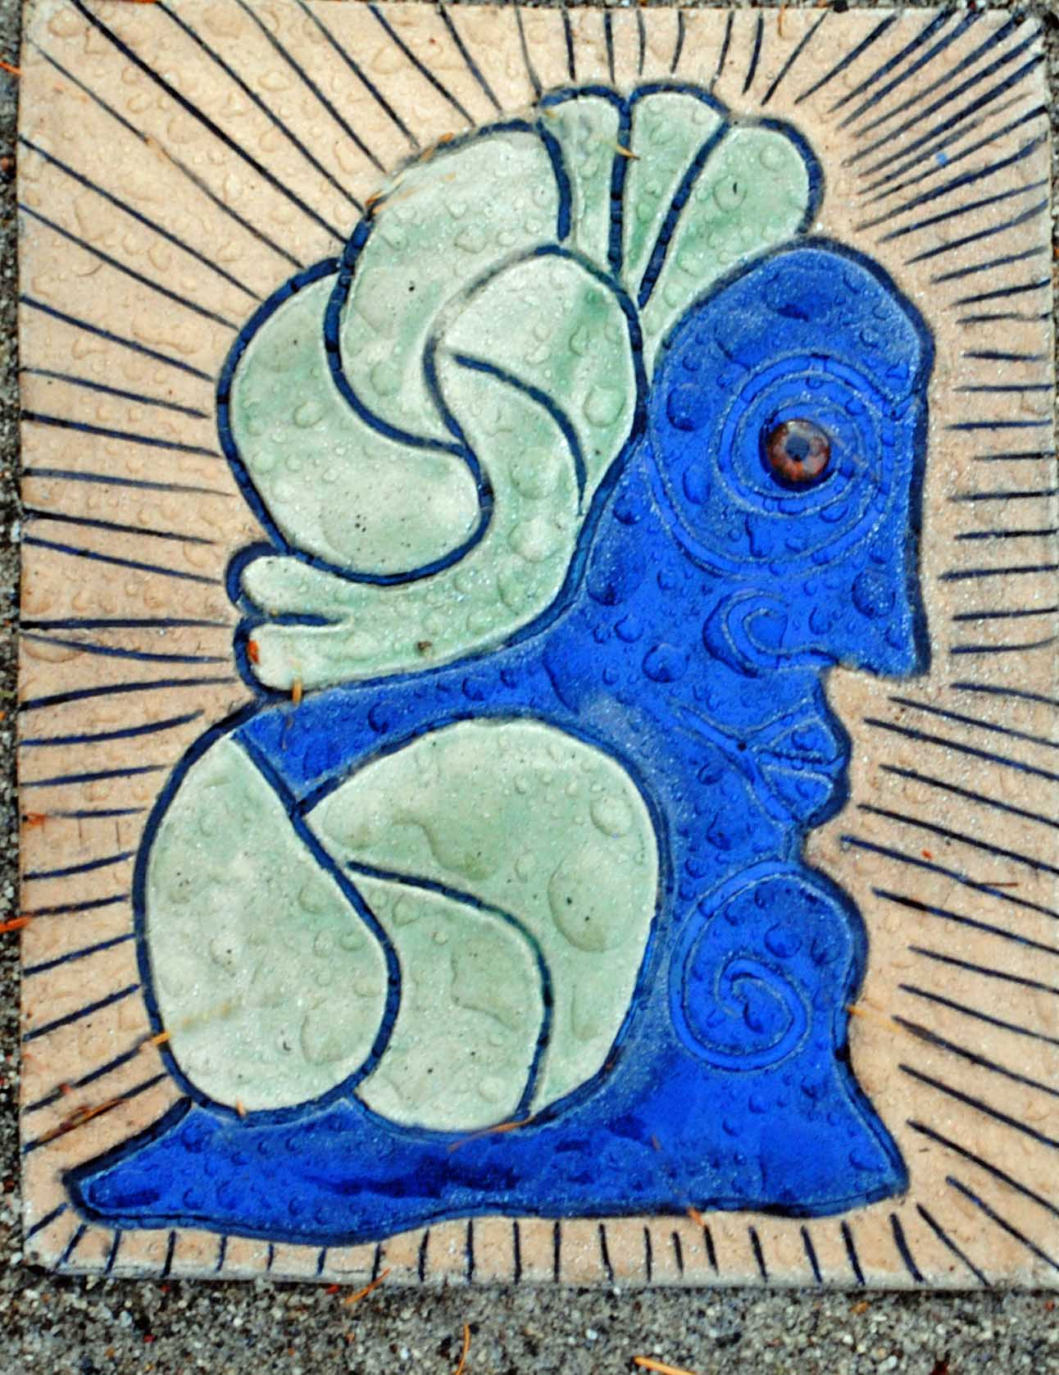
I. In the beginning was the Word…Fireball…Flaring Forth…Big Bang…Void. Which of these names of our origins speaks most directly to you?
"Oh Spirit, Teach me anew and in the context of a new universe story what it means that all creation, myself included, was 'loved from before the beginning.'

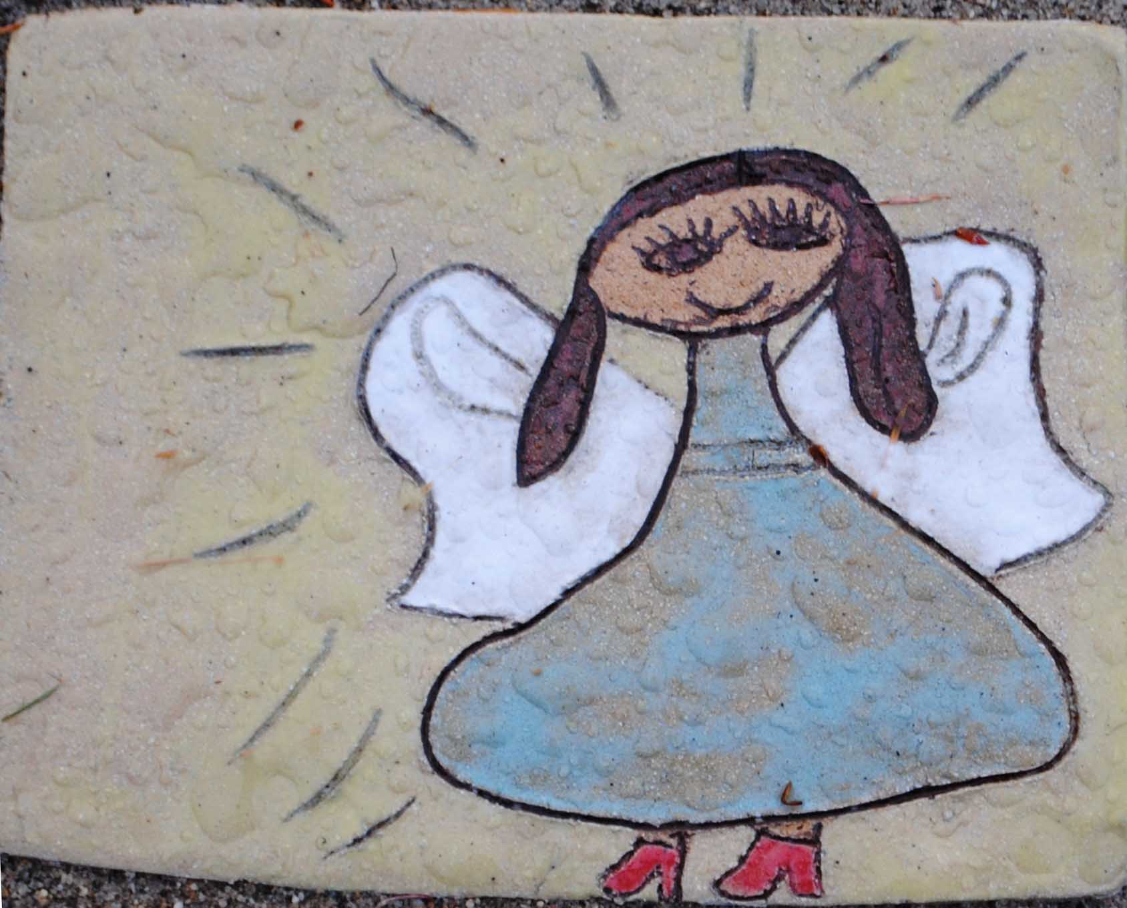
II. "I Am the light of the world." How am I the light of the world? How am I not? How can I allow more light to shine? How is the culture I am part of a light of the world? How not? How can I improve?
"O Spirit, Teach us how to become a light to the world and to link up with other lights to enlighten our species in these trying times."

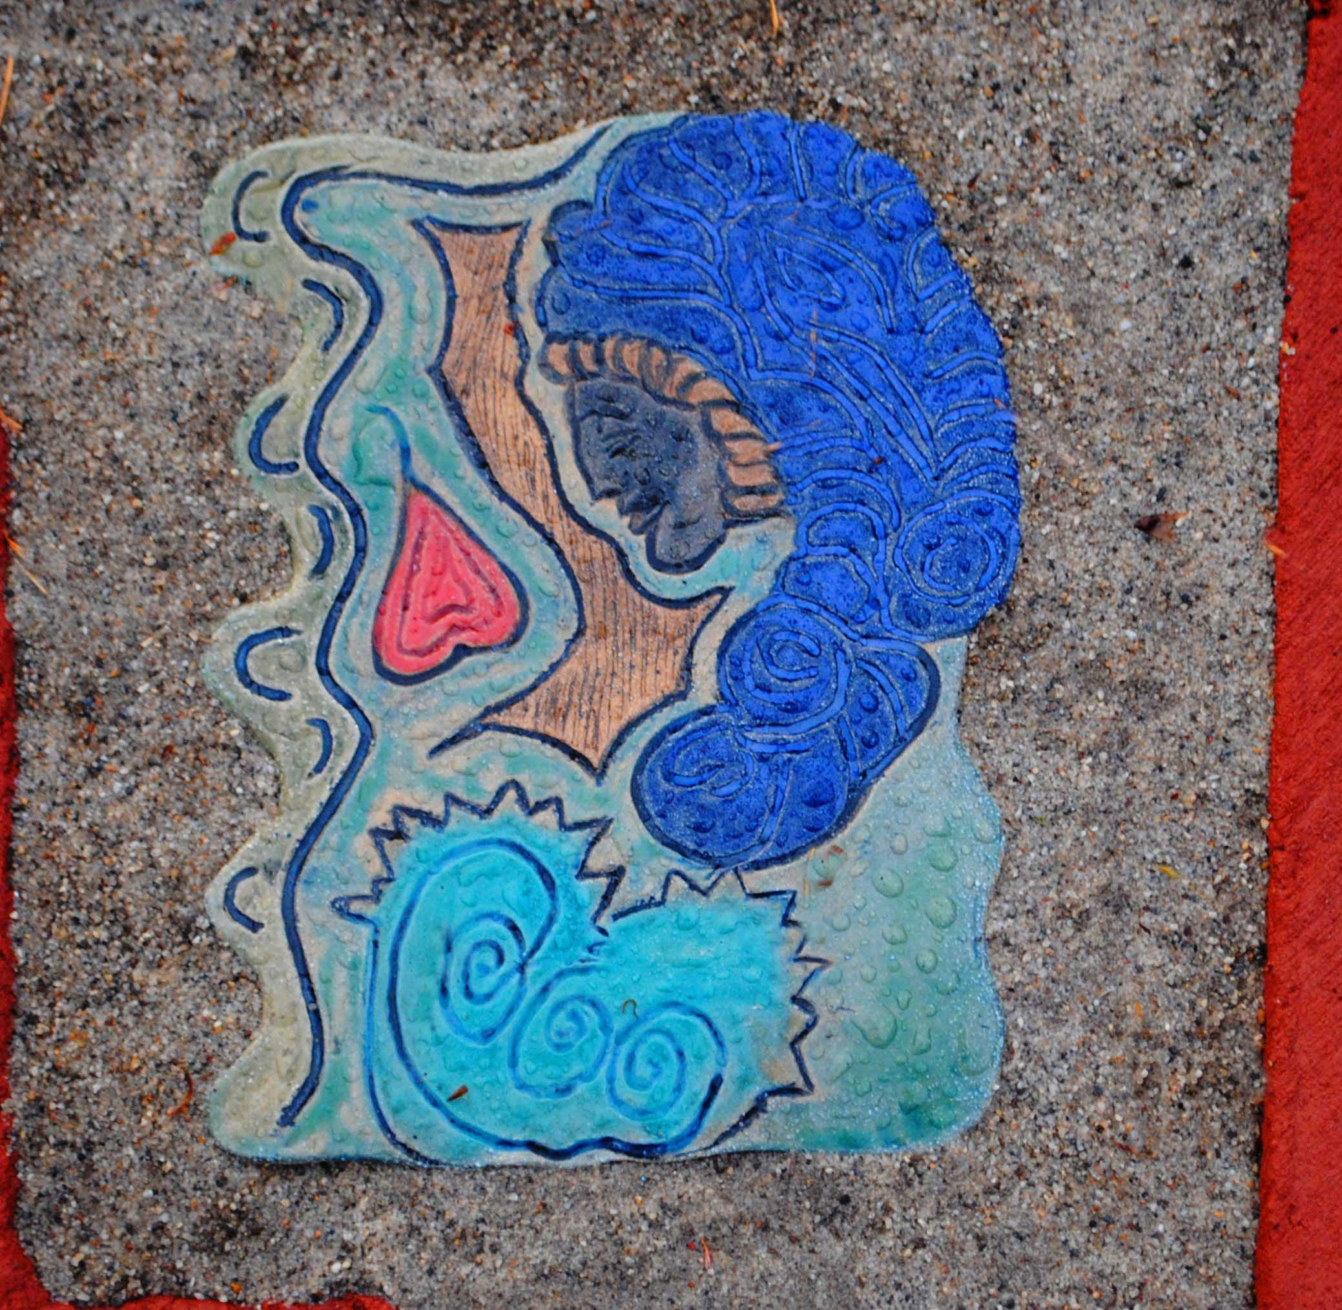
III. Nativity How meaningful is it that the animals and angels, shepherds and pagan wise men, stars and Jesus' parents are all involved in the birth of the Christ - wherever that happens?
"O Spirit, Lead us into a fuller recognition of the God-self and Cosmic Christ we behold in every creature, and especially the newborn ones, those beginning life with so much promise and eagerness. Give us the grace to parent them wisely."
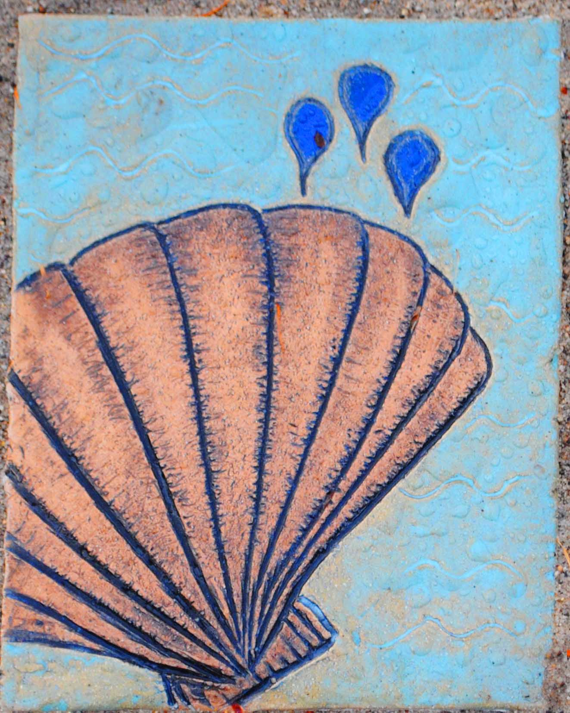
IV. Baptism How have I undergone vision quests or similar breakthroughs that have revealed my deep calling and purpose for being on this earth at this special time?
"O Spirit, Grace me and others with the courage and generosity to respond fully to my calling and see my work and relationships in light of that vocation. Grant me flexibility and creativity also to adjust that calling as the times dictate and as the needs of my culture require."

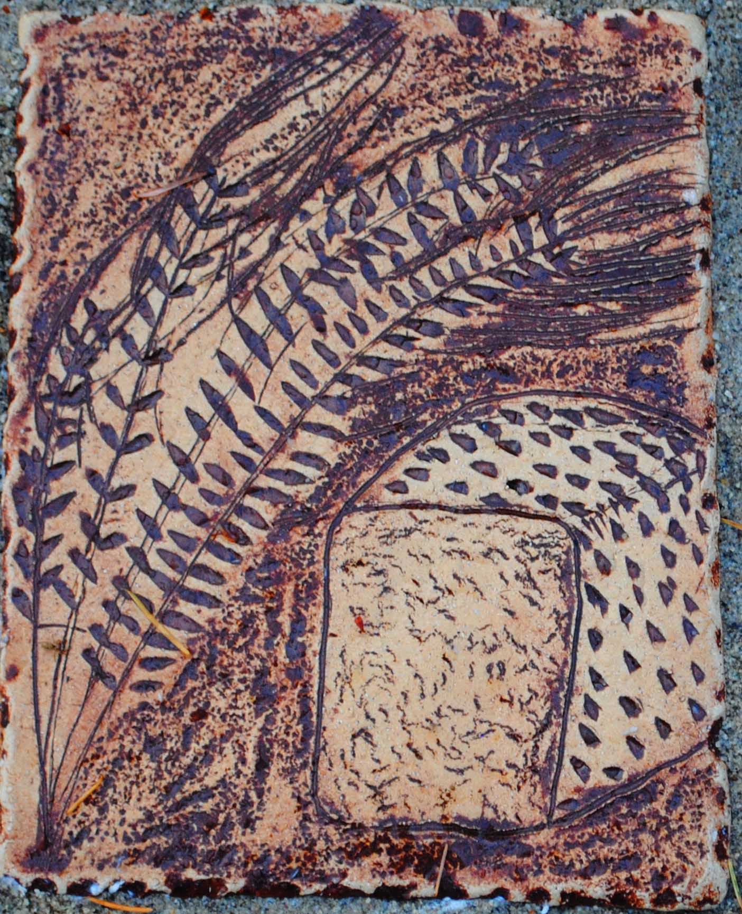
V. I Am the Living Bread (the Bread of Life) How am I "Living bread for others?" How am I not? How can I become living bread for and with others?
"O Spirit, Teach me to become living bread and nourishing food for others. Teach me to seek out others who are living bread for myself and so we can together be living bread for others. Teach me how my work can offer living bread for others."

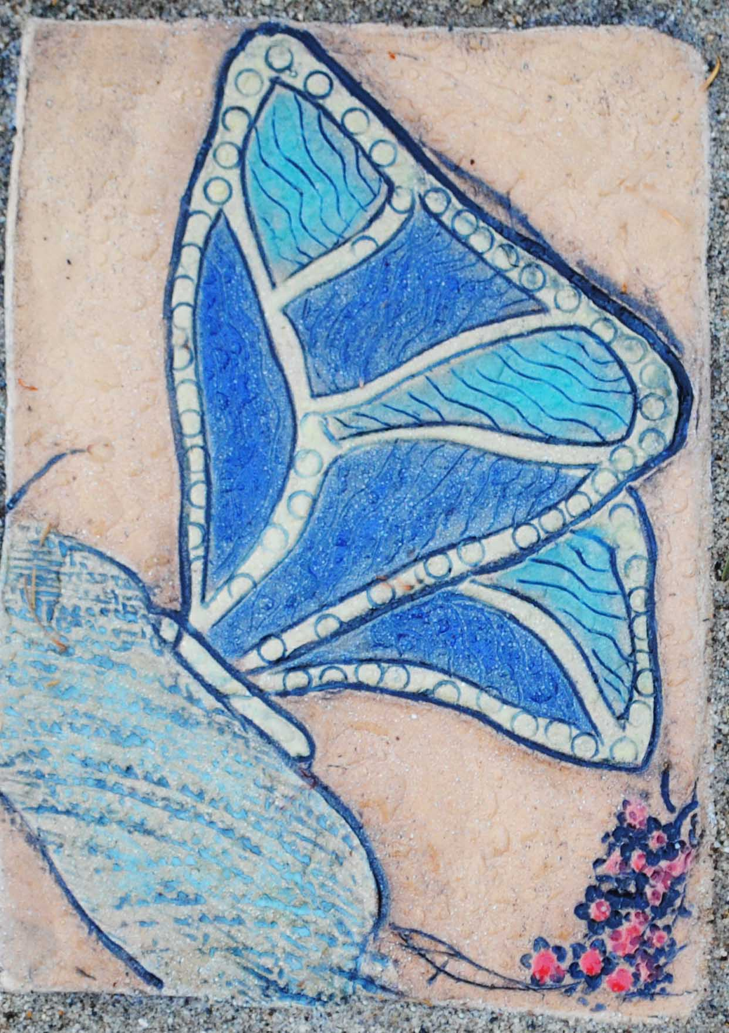
VI. The Transfiguration Have I come to grips yet with my inner self- the place where the son of God, image of God and Cosmic Christ dwell?
"O Spirit, Teach me the dep truth of my own --- and our own---God-like-ness and Christhood, and what it means for my citizenship and work, and all our relations. Speak in the fashion you choose, to remind us that we too are the Beloved 'and enjoy your favor'."

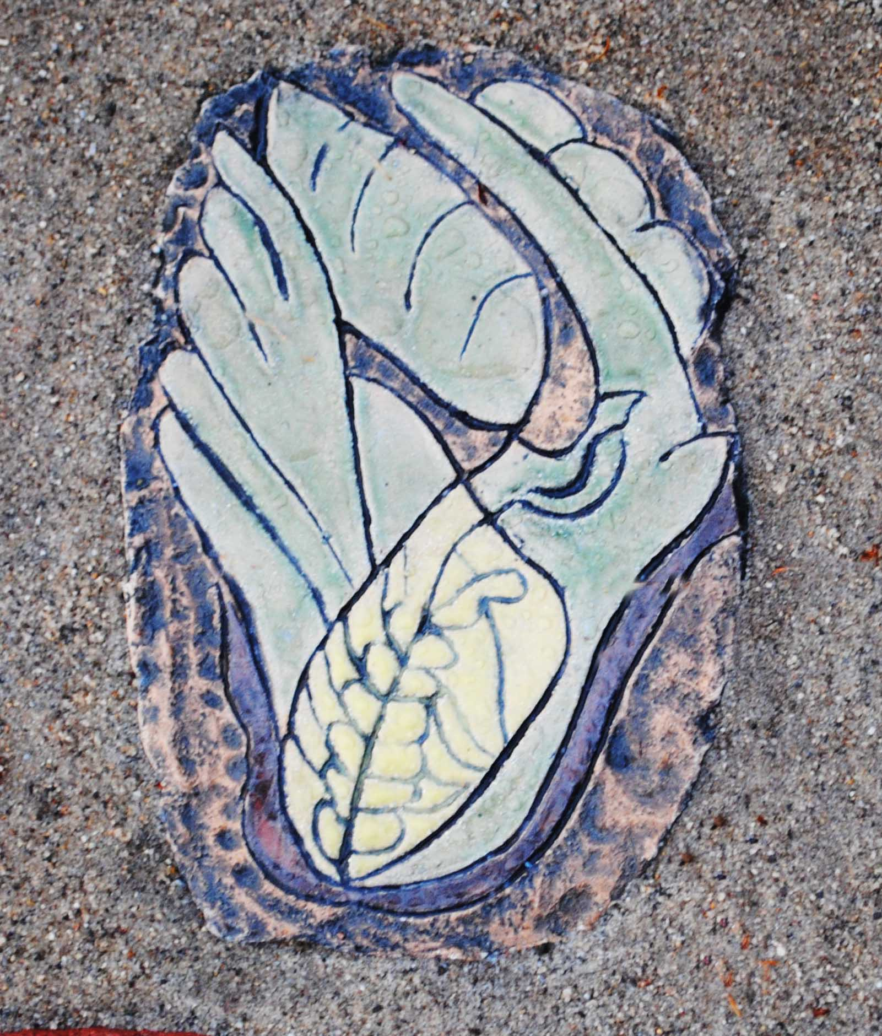
VII. I Am the Vine How am I a vine? Am I a strong and sturdy and determined vine, like Jesus was, and that I am called to imitate?
"O Spirit, Teach me to become a vine that is strengthened by the prunings that life demands of us, and which does not wither but grows ever greener and ever stronger…. And which links up with other Christs who are doing the same."

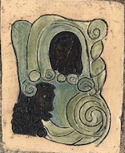
VIII. Do it to the least and you do it to me What are the implication of this teaching of the Christ in others, especially in the "least," for my calling and my work in the world?
"O Spirit, Open my heart and my ears to hear the cries of the poor and those denied a voice. Let me have the courage to recognize suffering for what it is and the imagination to respond to it in effective ways. Let me find allies, and let us change our structures, moving them towards community and sustainability and away from imbalance and injustice."

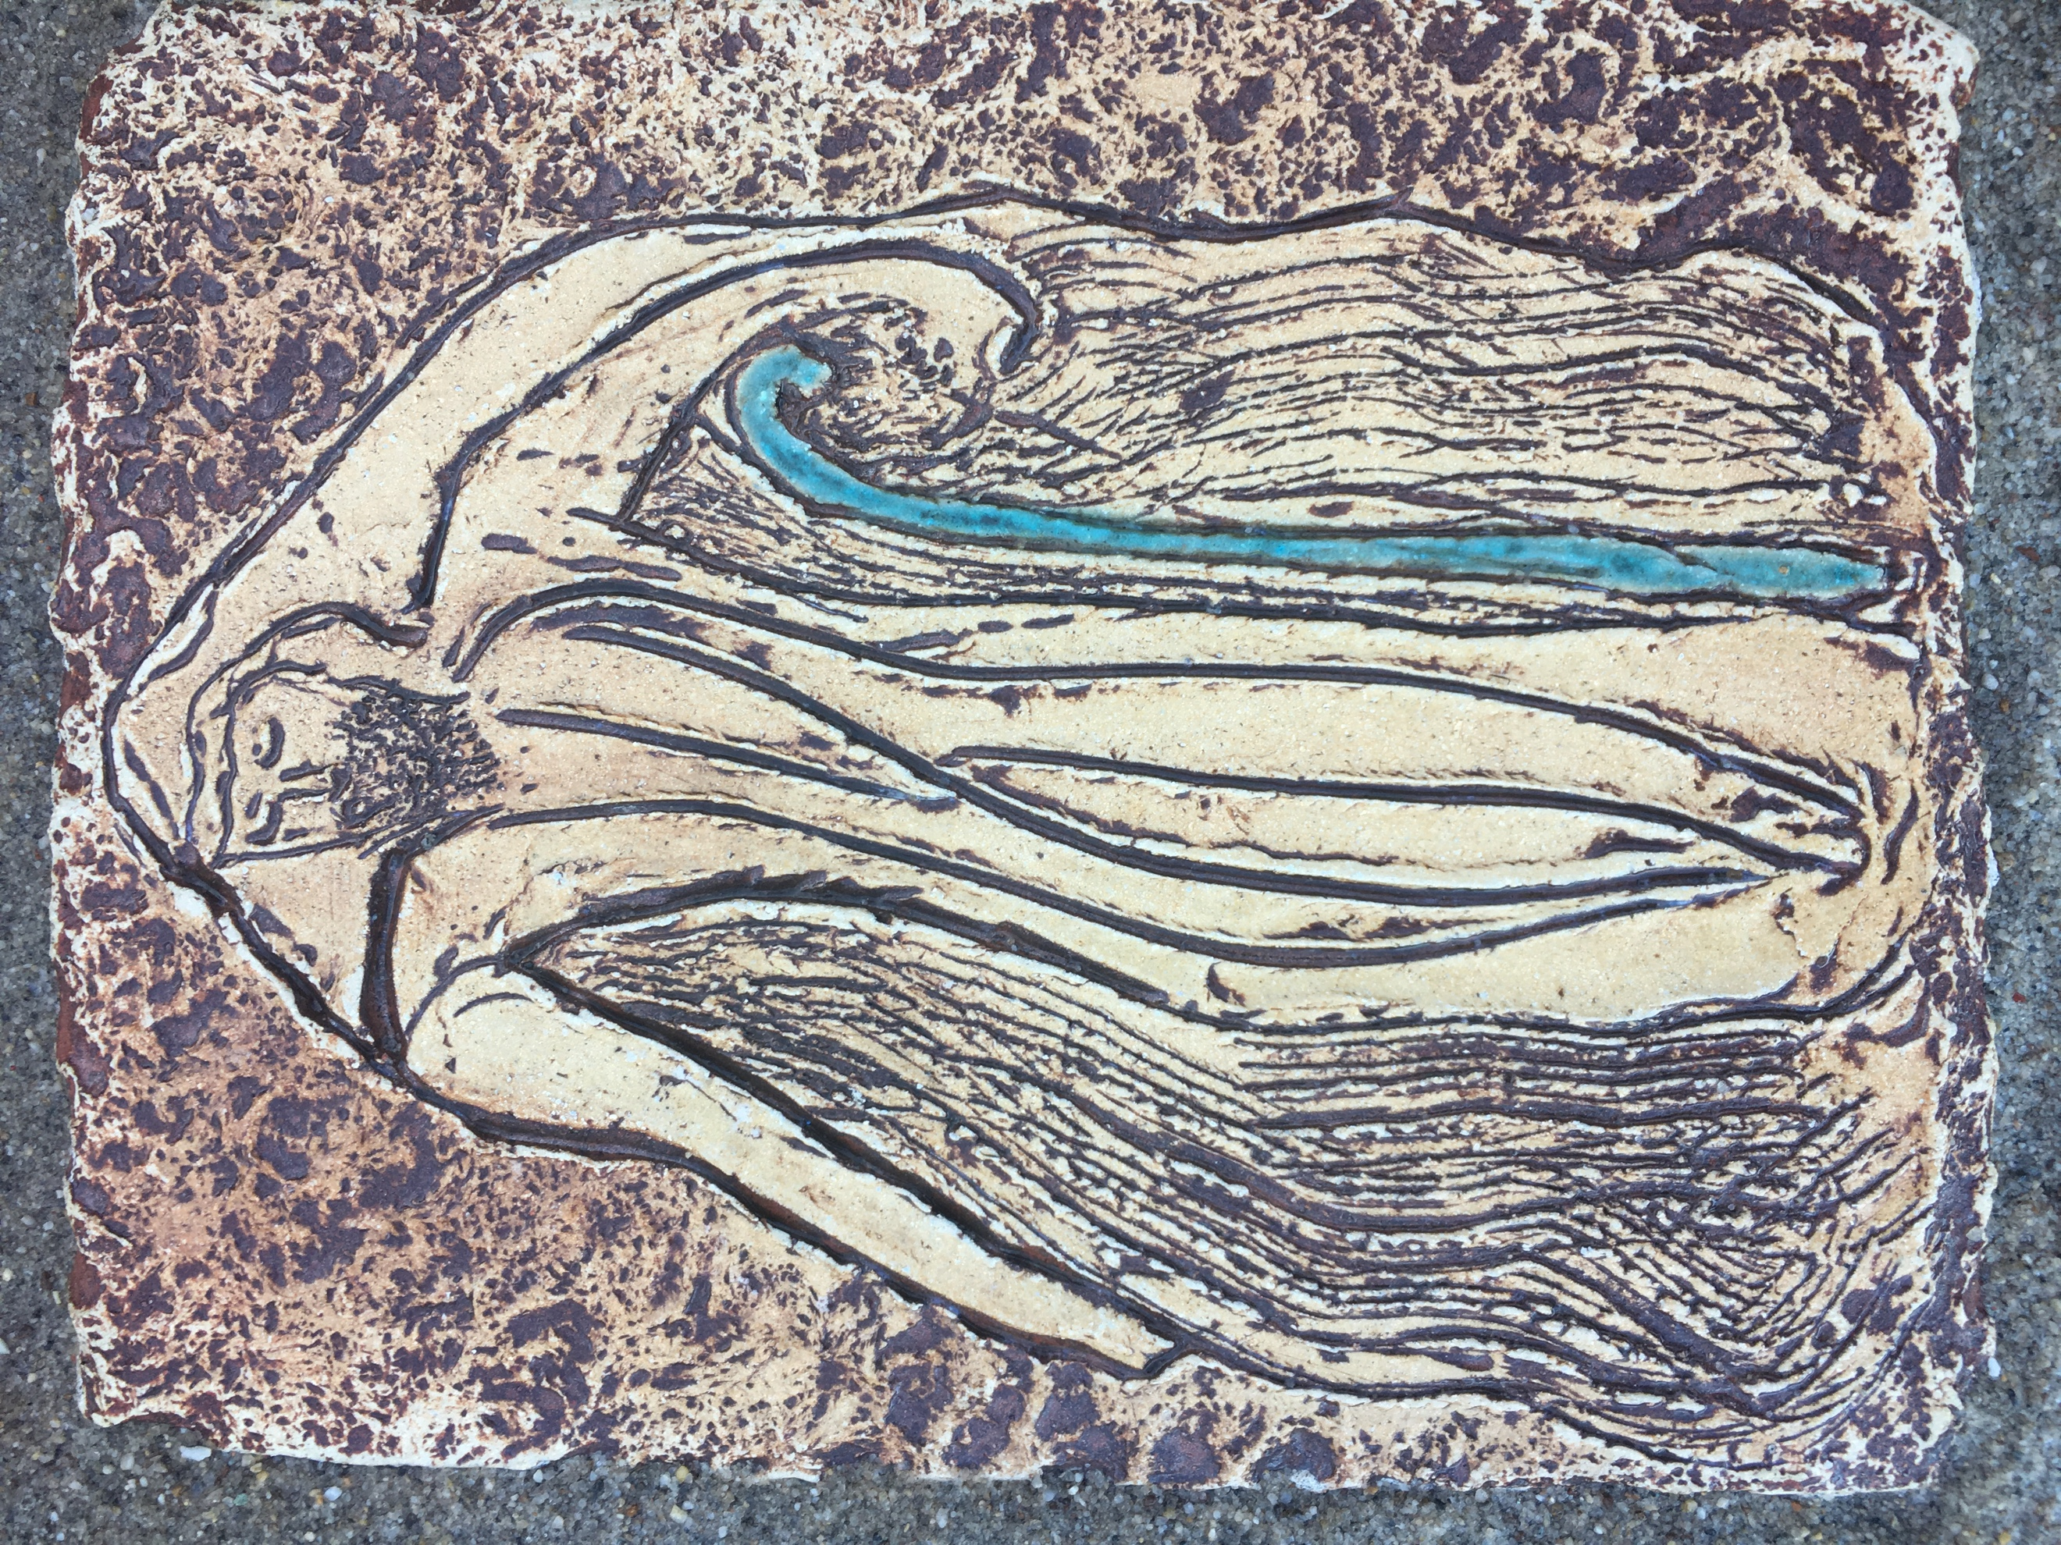
IX. I Am the good shepherd How am I a "good shepherd" and steward of the Earth and her creatures? How can I link up with others to make a difference, to defend Mother Earth?
"O Spirit, Teach us the courage and trust that will allow us to stand up on behalf of those we are charged to protect---the future generations of children and grandchildren for generations to come---so that they may delight in a healthy, holy and clean planet full of diverse plants, animals, sea creatures, and birds."
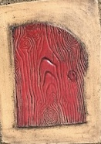
X. I Am the door (the gate, the way) How am I a door or a gate for others?
"O Spirit, Make of me a useful door, a door that is wise enough to know when to be open and when to be closed, when to cherish solitude and when to practice hospitality. Bless me with curiosity so that I may go hunting for the truth and beauty and greatness that lies behind the Christ doors in the world."

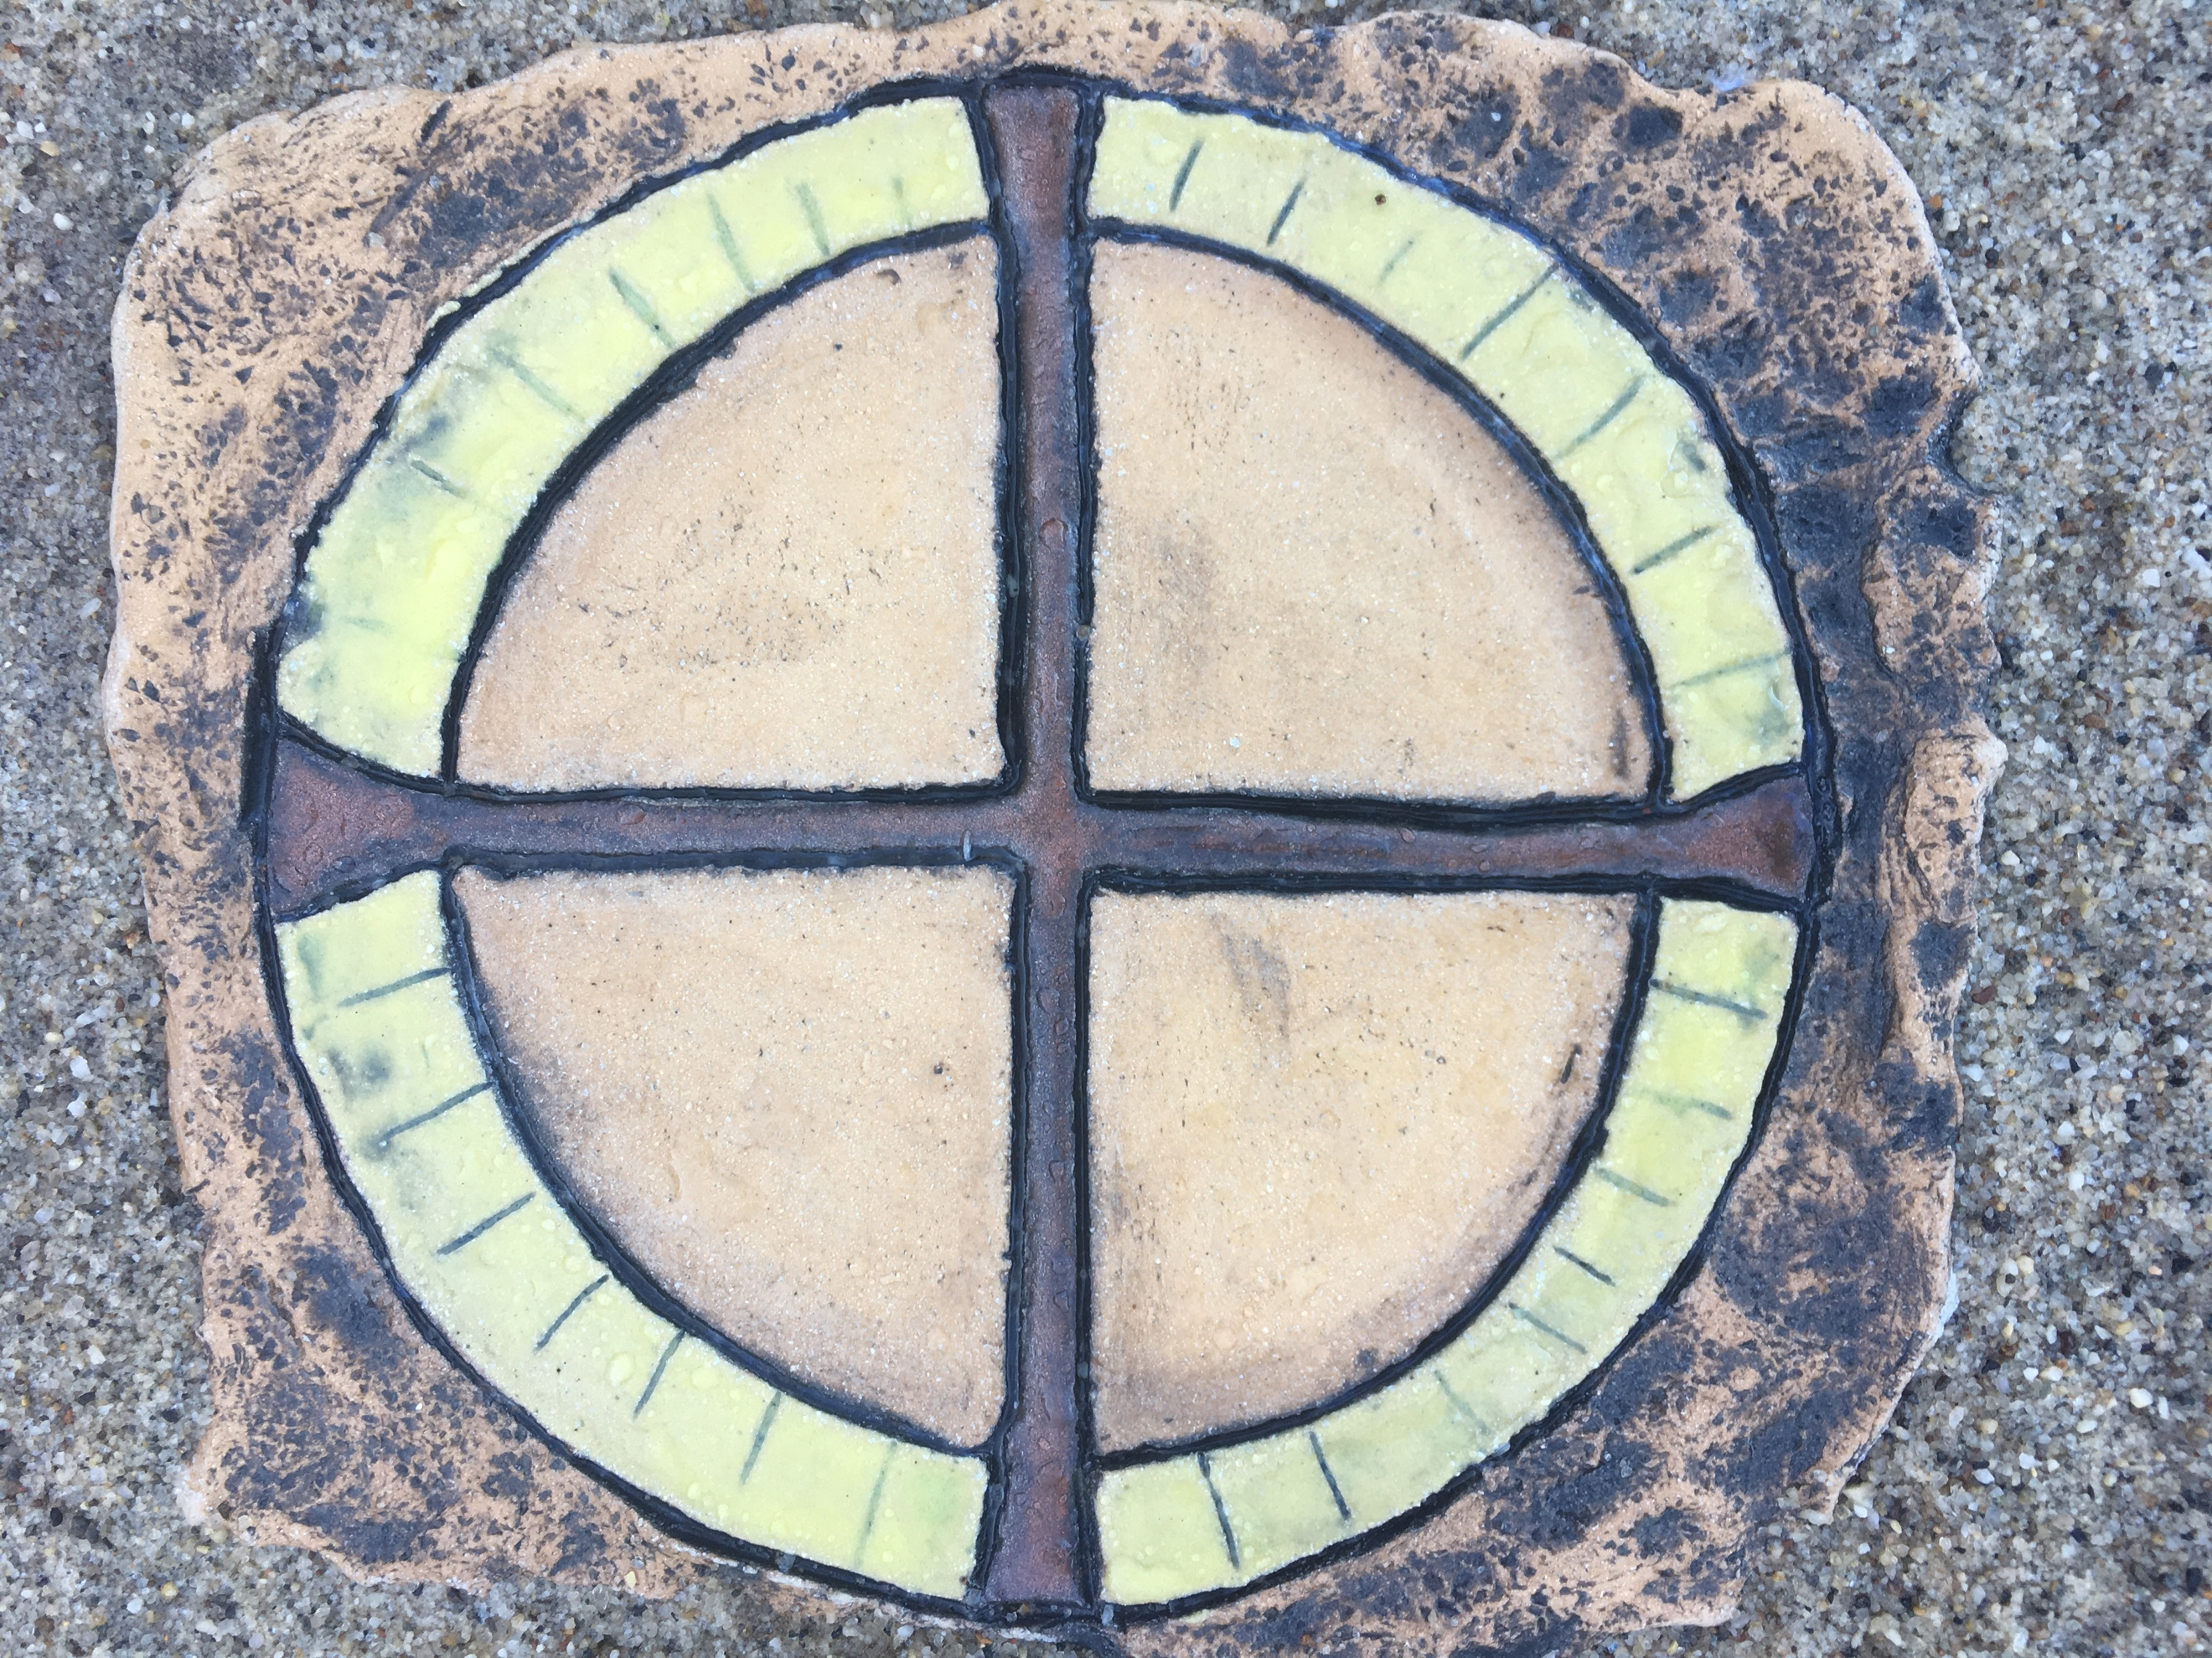
XI. I Am the Way, the Truth and the Life Am I a person on the Way, a person hungry for Truth and full of Life?
"O Spirit, Teach me to be a lover of Life. To be a champion for Truth and a fearless hunter after it, to be a wayfarer, a pilgrim, and a traveler on life's highway. Bring people into my world who can assist me in life-loving, truth-finding, and walking a common Way together."

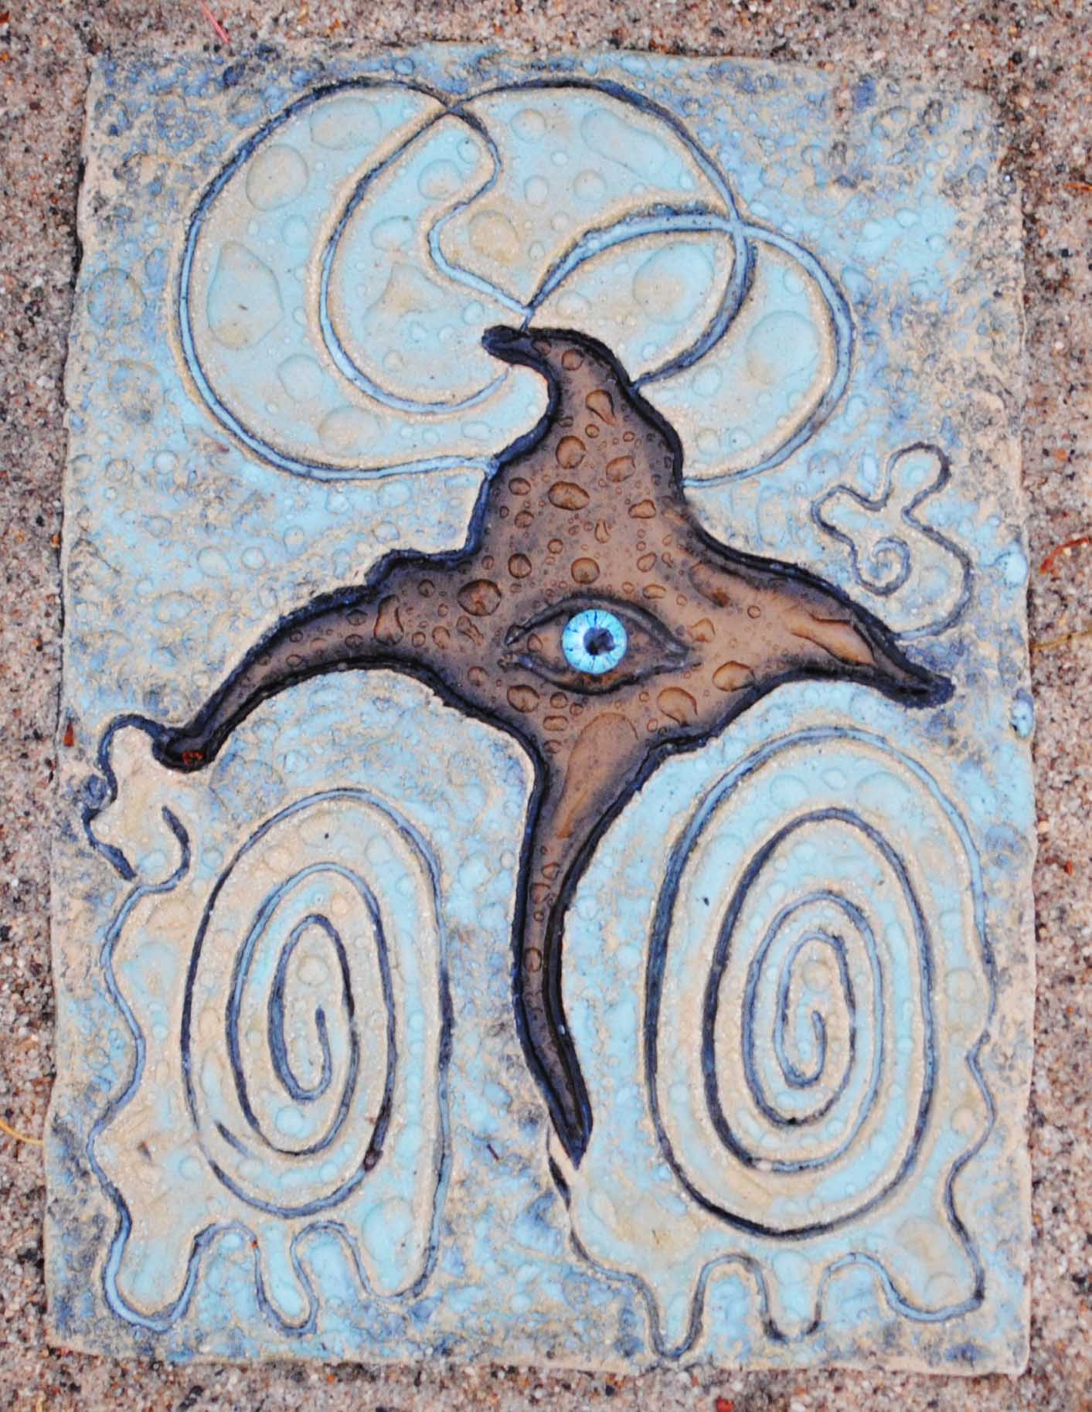
XII. The Crucifixion The Crucifixion reminds us of the university of suffering. All beings suffer; including the Christ in Jesus and in all living things.
"O Spirit, Open and stretch our hearts. Let suffering deepen and widen our souls, our consciousness, the way we understand the world and one another. Teach us what we have to learn from the Dark Night and from suffering. Lead us into circles of people where we can teach one another what grieving means, how it can deepen and refresh us, how it can make us more beautiful beings who serve one another and try to lessen what suffering we can."

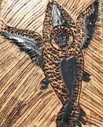
XIII. The Resurrection The Resurrection is happening daily and cosmically. All beings --- even stars and supernovas and galaxies---live, die, and resurrect.
"O Spirit, Make me a being who has tasted resurrection and is grateful for it. Make me one who sees the Joy in life even through the pain of suffering and loss. Make me one who truly believes in resurrection and who joins all the resurrected ones, those who have moved from death to new life.

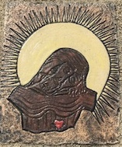
XIV. "I Am the Resurrection and the Life." Am I resurrection for others? How am I that aspect of the Cosmic Christ? How might I become the resurrected Christ more fully? Am I life for others?
"O Spirit, Teach me the truths of resurrection and resurrecting, and the deepest truths of Life it self, now, in this life. How many times have I died? And how many times have I resurrected? Or refused to resurrect? Grant me the courage to let go, and the trust to forgive, move on, and to live life fully, even when death in any of its forms assaults me."

XV. Ascension The Ascension reminds us to move out, to expand-- like the universe is always expanding. In other words, to grow.
"O Spirit, Befriend the expansion of our souls, the joy that grows our souls, the learning that expands our consciousness; and our moving beyond rigid tribal boxes of religion, ethnicity, nationhood, or gender to become the fulsome and expanded people we are meant to be."

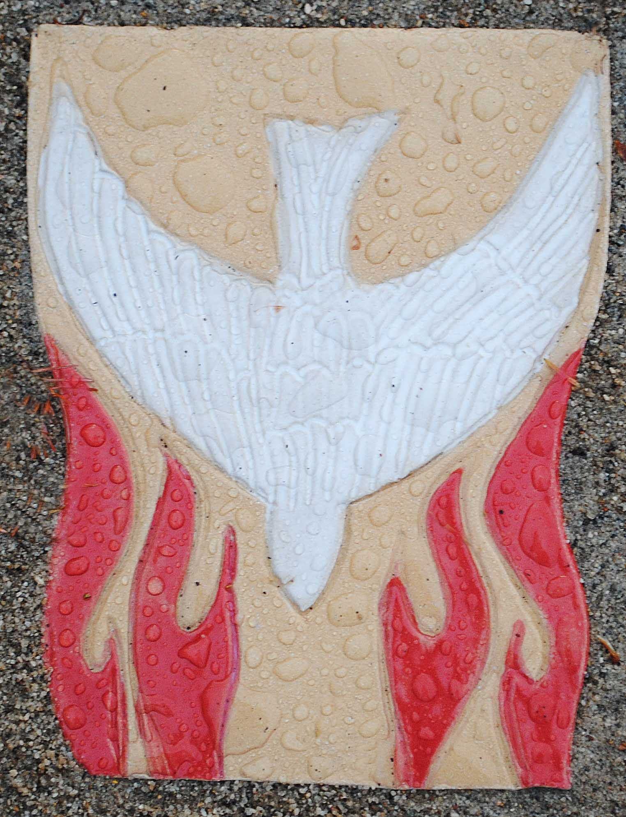
XVI. Pentecost The Pentecost event promises us that the spirit will be poured out "on all humankind, " and that the young and old will be alive with intergenerational wisdom and creativity, birthing new ways of relating and communicating.
"O Spirit, Make of me a person endowed with a Spirit that heals divisions and brings tribes together instead of keeping them apart. Endow me with a Spirit that unites Father Sky and Mother Earth into a Sacred Marriage, one that embodies a balance of Compassion and of Justice, action and contemplation, becoming and being."

